UNIT 3 ASSESSMENT
1. Determine the following: [K4]
a. Given a sector with an arc length of 4.5 cm and a radius of 3 cm, find the angle subtended by the arc

$θ=\frac{arc length}{radius}$= $\frac{a}{r}$ $\frac{3}{2}$×$\frac{180}{π}$= 85.94°
$θ=\frac{4.5}{3}$= $\frac{3}{2}$radians Therefore, the subtended angle by the arc is $\frac{3}{2}$radians or 85.94°.

b. Given a sector with an angle of 13 radians and a radius of 7 m, find the arc length.
s = r$θ$
s = 7(13) = 91 m Therefore, the arc length is 91 m.

2. Fill in the table. Show your work and keep answers exact. [K4]
Degrees | Radians
$\frac{2π}{45}$($\frac{180}{π}$) =  = 8° | $$\frac{2π}{45}$$
230° | 230° ($\frac{π}{180}$) =  = $\frac{23π}{18}$

Answer:
Degrees | Radians
﻿8∘​ | 452π​​﻿

﻿230∘​∣1823π​​﻿
Explanation:
Using, ﻿π Radian = 180∘﻿

Converting ﻿452π​﻿ radians in degrees will be as follows:

﻿⇒452π​=452×180∘​=8∘​﻿

And converting ﻿230∘﻿ degrees in radians will be:

﻿⇒230∘×180∘180∘​=230∘×180∘π​=180∘230∘​×π=1823π​​

3. Determine the values of θ if 0 ≤ θ ≤ 2π given that cosx = − 0.3178. Explain your process. [K4], [C2]
Answer
The terminal arms may be drawn in such quadrants to compute the related acute angle ß.
cosx = − 0.3178
= −0.3178 x = cos−1(−0.3178)
= 1.8942
Then, cos (1.8942) =−0.3178
Quadrant 2:
θ1 = π −β
θ1 = π−1.8942
θ1 = 1.247

Quadrant 3
θ2 = π +β
θ2 = π +1.247 Therefore, the values of θ are 1.8942 and 4.3886.
θ2 = 4.3886

4. Determine exact values of θ if 0 ≤ θ ≤ 2π given that tanθ = − √ _ 3. Explain your process. [K4], [C2]
Answer
tanθ = − 3
θ = arctan (-3) To isolate x, apply the inverse trigonometric function
θ = - $\frac{π}{3}$ Using a unit circle or a trigonometric values’ table, find the value of arctan (-3)
θ = $\frac{2π}{3}$ Find the smallest positive angle coterminal to - $\frac{π}{3}$
Therefore, 120° is the exact value of θ

5. Describe the transformations on the given cosine function. [C4]
f(x) = 0.5cos [0.5(x − π)] − 12
Answer
f(x) = 0.5cos [0.5(x−π)] − 12
a = 0.5: Vertical compression by 0.5
k = 0.5: Horizontal stretch $\frac{1}{0.5}$= 2
d = -$π:$we obtain d by setting x+$π=0,$therefore, isolating x. $π$ units left because d is negative
c = -12: 12 units down because c is negative

6. Find an equation for each function and explain your thought process.
a. A sinusoidal function with an amplitude of 15 units, a period of π/2, a phase shift of π/7 radians to the right, axis at y =33 [A4] [C2]
Answer
a = 15
k = 4
d = $\frac{π}{7}$ Therefore, the equation of a sinusoidal function is
c = 47.624 f(x) = 15sin[4(x-$\frac{π}{7}$)]+47.624
Answer for number 6 (b)

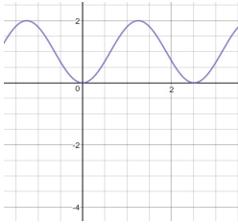
f(x) = cos (3x - $\frac{6π}{6}$) + 1

7. Determine the exact value of tan5 π/12. [T4]
Answer
tan $\frac{5π}{12}$= tan $\frac{π}{6}$+$\frac{π}{4}$= $\frac{tan( \frac{π}{6})+ tan(\frac{π}{4})}{1-tan(\frac{π}{6}) tan(\frac{π}{4})}$= $\frac{\frac{\sqrt{3}}{3} +1}{1-\frac{\sqrt{3}}{3}× 1}$= $\frac{\frac{\sqrt{3}}{3} +1}{1-\frac{\sqrt{3}}{3}}$=$\frac{\frac{\sqrt{3+3}}{3} }{\frac{3-\sqrt{3}}{3}}$= $\frac{\sqrt{3} +3}{3- \sqrt{3}}$=$\frac{(\sqrt{3} +3)×(3+\sqrt{3})}{6}$= $\frac{(\sqrt{3} +3)2^{}}{6}$= $\frac{3+6 \sqrt{3} + 9}{6}$= $\frac{12+6 \sqrt{3} }{6}$=$\frac{6(2+\sqrt{3})}{6}$=$2+\sqrt{3}$

8. Determine a value of x for each of the following. Give answers in simplest exact form. [A6]
- sin$\frac{8π}{23}$= sinx, x $≠\frac{8π}{23}$

sin$\frac{8π}{23}$= sin (x+2$π)$
(sin$\frac{8π}{23}$)$÷sin =(sin(x+2π))÷sin$
$\frac{8π}{23}$= x+2$π$
$\frac{8π}{23}$-2$π$= x
x = $\frac{8π}{23}$-2$π$
x = $\frac{8π}{23}$-$\frac{46π}{23}$
x = -$\frac{38π}{23}$
- cos $\frac{11π}{31}$= sinx
cos $\frac{11π}{31}$= cos ($\frac{π}{2}$- x)
(cos $\frac{11π}{31}$)$÷cos =(cos(\frac{π}{2}-x))÷cos$
$\frac{11π}{31}$=$\frac{π}{2}-x$
$\frac{11π}{31}$-$\frac{π}{2}= -x$
x = $\frac{π}{2}$ -$\frac{11π}{31}$
x = $\frac{31π}{62}$ -$\frac{22π}{62}$
x = $\frac{9π}{62}$
- tan$\frac{π}{8}$= cotx
tan$\frac{π}{8}$= tan ($\frac{π}{2}$- x)
$\frac{π}{8}$= $\frac{π}{2}$- x
x= $\frac{π}{8}$- $\frac{π}{2}$
x= $\frac{4π}{8}$- $\frac{π}{8}$
x= $\frac{3π}{8}$

9. Prove the following identity. Explain your thought process. [T3] [C2]
cot²x = $\frac{1+ cos2x}{1 - cos2x}$
$\frac{1+ cos2x}{1 - cos2x}$ Starting the break down from the right-hand side
$\frac{sin(x)2+cos(x)2+cos(x)2-sin(x)2}{sin(x)2=cos(x)2-(cos(x)2-sin(x)2)}$ Expanding the expression
$\frac{2cos(x)2}{2sin(x)2}$= $\frac{cos(x)2}{sin(x)2}$ Removing all two opposites, like terms, from the expression.
Reducing the fraction with 2

$\left(\frac{cos(x)}{sin(x)}\right)$² After the numerator and denominator are raised to a similar power, we raise the entire fraction to such power.

cot2(x) Transforming the expression

10. Solve the following trigonometric equation for 0 ≤ x ≤ 2π. Explain your process. [A4] [C2]

cos² x − 1 = 0
-sin²(x) = 0
sin²(x) = 0
sin²(x) = $±\sqrt{0}$
sin(x) = 0
x = arcsin (0)
x = 0
11. The depth of water in a harbor varies as a function of time. The maximum depth is 9 feet and the minimum depth is 1 foot. The depth can be modelled with a sinusoidal function that has a period of 12 hours. If the depth is 5 feet at 12 midnight, and is increasing,
a. Create an algebraic model to predict the depth of the water as a function of time. Justify your reasoning. [T4] [C2]
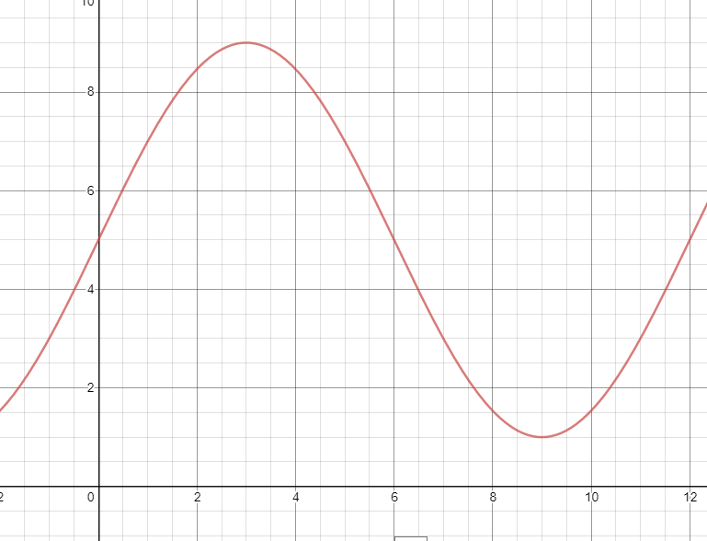
Answer
t=time
f(t) = 4sin (($\frac{π}{6}$)t)+5

b. The water must be at least 7 feet for Annie’s fishing boat to safely navigate the harbor. She wants to enter the harbor during the afternoon.
i. Create a graph of this function using technology. [T2]
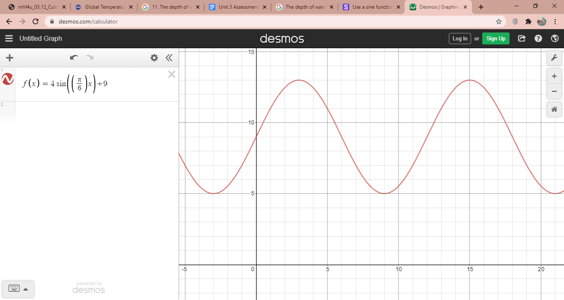

ii. What is the earliest time she can enter the harbor? [T2]
11 am is when she can enter the harbor since the water will be at 7 feet during that time and this implies that Annie can navigate the fishing boat safely in the harbor.
iii. How long can she safely stay in the harbor? [T2]
Annie can take a safe stay of 8 hours if she will enter the harbor at 11 am.

